
Website Admin Manual

Volunteer Capabilities

First-time Volunteer sign-up
Click on "Want to Volunteer?" in the footer (this takes the user to /htcs/volunteers/new)
When the user fills in the information, they are shown a thank-you. Internally they get a volunteer account created with a random password.

Logging Hours
Click on the "Volunteers" link in the upper-right-hand side of the website (this takes the user to /volunteers/sign_in) and login with your volunteer credentials, you are automatically brought to the "Current Work Hours" screen, which shows you your hours for the past 15 days:

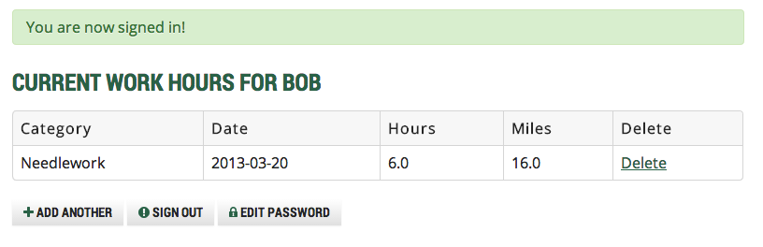

Use the "Add Another" button to add more hours to the volunteer system:

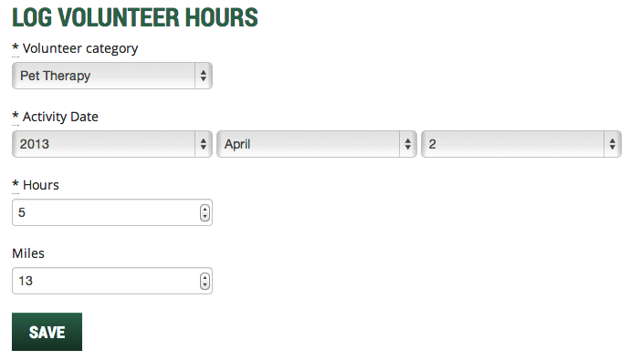
Use the "Sign Out" button to logout of the volunteer system. The "Edit Password" button takes you to a screen where you can edit your password (must be currently logged-in as a volunteer to edit your password).

Admin Capabilities
All of these admin capabilities are accessed after logging into the refinery admin page (just add /refinery to your url) unless otherwise noted

Managing Volunteers

Viewing the list of pending volunteers
ou can simply login (/refinery) and then click the Volunteers page tab. Alternatively, you can go to /refinery/htcs/volunteers.

You will see a list of volunteers and their status:

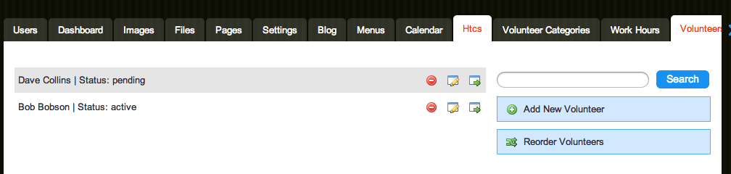
Volunteer status will be "pending" if they have signed up but not been approved by an admin. Their status will be "active" after you "promote" them to an active volunteer.

Approving a pending volunteer

To promote a volunteer to active status:
Click the "Edit" button
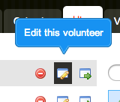

Then check the "promote" checkbox
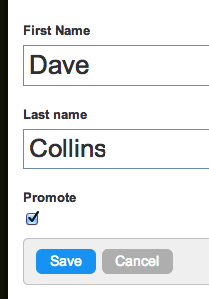
… and click Save to save them.

Once promoted to active status, volunteers password is reset to "changeme" and they are expected to login and change their password. As an alternate activation plan, you might login as them and change their password for them.

There is another way to list all of your volunteers, and that is with the /volunteers URL. This gives just a simple list of all active volunteers:

Each name is a hyperlink to a bit more information about the volunteer. Also, from this screen you can easily access the creatively-named "Work Report" outlined in the next section.

Volunteer Reporting

Running the Work Report
From /volunteers click on the "Work Report" button or, simply go to /workreport. (Note: If you are not logged in, you will be redirected to the Refinery Login Prompt, then placed at main menu.)

You will see a screen where you can enter your work report selection criteria:
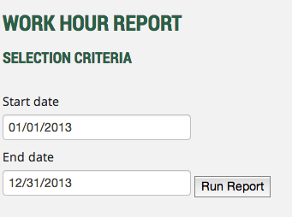

Adjust the dates as you see fit, and click "Run Report" to view the glorious Work Report:

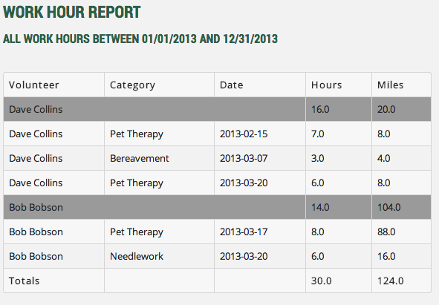
Hours and Miles are totaled for each volunteer as well as for the entire date range.

